Doctoral Dissertation

Comparative Study on the Root Positions
in Virtual Tooth Setups for Extraction Cases
between Simulated and Achieved Treatment Results

Department of Dental Science
Graduate School, Chonnam National University

Mirinae Park
Supervised by Professor Kyung-Min Lee

February 2021
Contents

 |  | Abstract···························································································· | 1
I | . | Introduction······················································································· | 3
II | . | Material and Methods··········································································· | 6
III | . | Results······························································································ | 16
IV | . | Discussion·························································································· | 20
V | . | Conclusion························································································· | 24
 |  | References·························································································· | 25
 |  | Korean abstract··················································································· | 31

Comparative Study on the Root Positions
in Virtual Tooth Setups for Extraction Cases
between Simulated and Achieved Treatment Results

Mirinae Park

Department of Dental Science
Graduate School, Chonnam National University
(Supervised by Professor Kyung-Min Lee)

(Abstract)
Introduction: The purpose of the present study was to compare the root positions in virtual tooth setups using only crown in simulated treatment with those achieved in actual treatment, and suggest a new approach for virtual setup process, including root positioning simulation, with tooth models fabricated by integrating intraoral scan (IOS) and cone-beam computed tomography (CBCT) data.

Materials and Methods: Intraoral scans and its corresponding CBCT scans before and after treatment were obtained from 15 patients who completed orthodontic treatment with premolar extraction. Three-dimensional (3D) tooth models at pretreatment and posttreatment were fabricated by integrating the intraoral scans and CBCT scans. Virtual tooth setup for treatment simulation was prepared. Subsequently, the virtual setup 3D tooth model was fabricated by merging the crown image from the virtual setup and the root image from the pretreatment 3D tooth model. The resulting expected root positions of the simulated pretreatment model were compared to those of the actual posttreatment tooth models. The discrepancy of the simulated and actual root position was measured for each tooth.

Results: The average discrepancy in the simulated and actual root position was 1.84 ± 0.27 mm and 2.15 ± 0.89° in the maxilla, 1.79 ± 0.46 mm and 2.23 ± 0.73° in the mandible, respectively. There was a statistically significant difference in the accuracy of the three-dimensional root position and inter-root angulation between the virtual setup and posttreatment 3D tooth models in all types of the teeth, except maxillary lateral incisors and first molar.

Conclusion: The virtual tooth setup using only crown data showed clinically acceptable accuracy and simulation for the root position. Clinical application of virtual setup using both crown and root is necessary for accurate and precise treatment simulation, particularly in extraction cases.

I. Introduction

Accurate diagnosis and treatment planning are important for successful orthodontic treatment. The goal of orthodontic treatment is to produce an ideal occlusion that is morphologically stable, esthetic and functional. After the plan is established, the study models and intraoral photographs are used for bracket positioning based on the plan, but these data provide limited information about the crown. Bracket positioning should be based on Andrews’ six keys. Andrews’ described six keys to achieve an esthetic and functional occlusion.¹ The principles of Andrews’ six keys are based on collecting information about the crown from the study model. However, because of variations in the morphology of the crown, two of these keys―mesiodistal angulation and buccolingual inclination―depend on the crown and root positions.²⁻⁷ Knowledge regarding the mesiodistal angulation, buccolingual inclination and the parallels between the roots is the basis for accurate and stable orthodontic treatment, and a panorama or cephalogram are typically used to check the root position. However, to reproduce the three-dimensional (3D) structure in two dimensions, a better tool may be necessary for evaluating the root position.⁸⁻¹²
To overcome these limitations, scanned images of the crown have been studied to visualize the root position three-dimensionally. However, since even scans with accurate crown data do not show the accurate three-dimensional position of the root, several studies have been conducted on merging scanned crown images and cone-beam computed tomography (CBCT) root images.¹³ Macchi et al. presented a method for establishing a treatment plan that considers the location of the root before orthodontic treatment by composing the laser-scanned image with the CBCT root image.¹⁴ Kihara and Lightheart then synthesized the laser-scanned crown image with the CBCT root image and to reveal the accuracy of the tooth model that visualized the three-dimensional root position.^{15,16} However, the methods presented in these studies used laser scanning of the cast teeth models, which requires implementing traditional impression techniques. To overcome the shortcomings of the previous studies, Lee et al. showed that the three-dimensional root position can be determined using intraoral scans during or after orthodontic treatment, and revealed that the root position after orthodontic treatments could be predicted using intraoral scanned images and CBCT images before orthodontic treatment.^{17,18}
When we simulate the orthodontic treatment plan, especially for extraction treatment, orthognathic surgery, or lingual orthodontic treatment with extraction, an orthodontic tooth setup and treatment simulation are essential. The conventional orthodontic tooth setup mostly used a tooth crown. Digital technology has increasingly been used to obtain three-dimensional (3D) models for diagnosis and treatment planning. Virtual occlusal records have been shown to be precise for contact size and location in virtual bite registrations with intraoral scanners. Since the introduction of intraoral scanners in dentistry and clinical practice, intraoral scans have replaced dental models and digital virtual tooth setup using intraoral scans has been widely used. Grünheid et al. evaluated the accuracy of virtual setup for Invisalign using surface-based registration in non-extraction cases.¹⁹ They compared the posttreatment model and virtual treatment plan model, however, in their virtual tooth setup, only tooth crown images were used; root images were not used.
In the orthodontic treatments with extraction, simulating the root position during virtual tooth setup is necessary to evaluate the root movement. Although it is ideal to perform accurate tooth setup using the crown and root for virtual tooth setup, there is no virtual tooth setup program that uses tooth crown and root together. As intraoral scanners do not contain root information, CBCT should be taken when the root information is necessary. However, the crown image of the CBCT is not clearer than the intraoral scanned image. Therefore, it is necessary to combine the intraoral scanned-crown images and CBCT root images. Also, owing to the large size of datasets, including all the roots of the whole dentition, a high computation load is required to run the software using crown and root data simultanelously.
Therefore, it is necessary to evaluate how accurately the virtual setup simulation reflects the movement of the roots. Thus, the purpose of the present study was to evaluate the accuracy of a virtual setup using intraoral scans and CBCT images to simulate root positioning and suggest a new approach to virtual setup process including root positioning simulation.

II. Materials and methods
1) Subjects
This retrospective study included patients with crowding or anterior protrusion who underwent conventional orthodontic treatment with premolar extraction at Chonnam National University Dental Hospital, Gwangju, South Korea. The inclusion criteria were as follows: (1) patients treated with upper and lower premolar extraction, (2) patients who had permanent dentitions and full clinical crown heights, (3) patients who had an CBCT and intraoral scanned data at pretreatment and posttreatment stage, (4) and patients who had proper occlusion and root parallelism at posttreatment stage. The exclusion criteria were as follows: (1) patients with teeth defects in need of bracket placement, (2) patients requiring postorthodontic restorative treatment, and (3) patients with incomplete pretreatment or posttreatment records.
The sample size was calculated according to the result of previous study by Lee et al. (Lee 2018), where the mean difference of buccolingual inclination measurements was 1.30 ± 0.92 and the effect size was calculated as 1.41. A statistical power of 80% and a type I error of 5% were assumed by the G*power program (version 3.1.9.2, Heinrich-Heine-University, Dusseldorf, Germany). The calculation indicated that 5 individuals were required in the study.
After the inclusion and exclusion criteria were applied, 15 consecutive orthodontic patients (4 males and 11 females) were enrolled. A total of 600 teeth (300 teeth with central and lateral incisors, canines, first or second premolars, and first molars in the pretreatment stage; 300 teeth with central and lateral incisors, canines, first and second premolars, and first molars in the posttreatment stage) were included in the study. The mean age was 18.8 ± 4.1 years. Thirteen patients underwent extractration of the 1st premolar, one patient underwent extraction of the upper right 2nd premolar, and one patient was missing state of the lower left 2nd premolar. The average treatment time was 31.1 ± 7.7 months. Of the 15 patients, 7 patients had skeletal Class I, 6 patients had skeletal Class II, and 2 patients had skeletal Class III relation.

Variable
Sample size (number) | 15
Gender (male/female) | 4/11
Age (y) | 18.8
ANB (〫) | 4.59
SN/MP (〫) | 39.76
FMA (〫) | 30.27
FMIA (〫) | 51.70
IMPA (〫) | 98.02
1 to SN (〫) | 110.26
1 to FP (mm) | 15.43
1 to FP (mm) | 10.49
UL to E-line (mm) | 2.06
LL to E-line (mm) | 4.82
Table 1. Demographic data of the samples included in this study.

2) Methods
Intraoral scans and its corresponding CBCT data were obtained before and after treatment from fifteen patients who have completed orthodontic treatment with premolar extraction. This study was conducted retrospectively to compare the crown and root position in the virtual setup and posttreatment 3D tooth models. The methodology to compare the virtual setup 3-Dimensional tooth model (3D tooth model) and posttreatment 3D tooth model is shown in Figure 1.
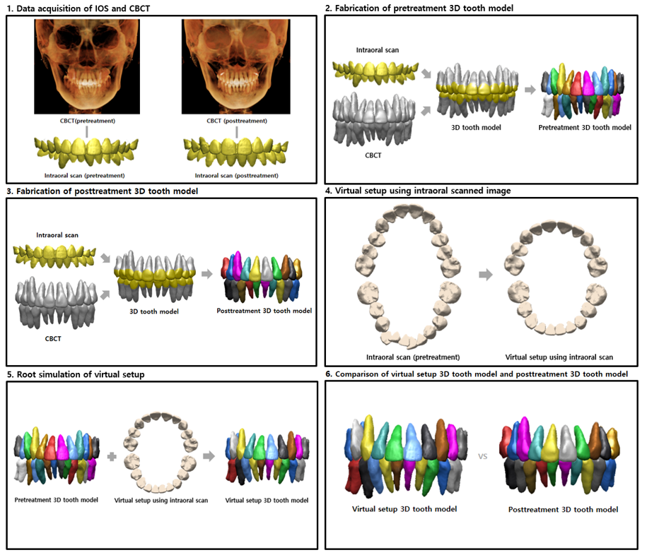Fig 1. Methodology to compare the virtual setup 3D tooth model and posttreatment 3D tooth model. The simulated root position is compared to the actual posttreatment CBCT root position.

Step I: Data acquisition of IOS and CBCT
The maxillary and mandibular arches were scanned using an optical intraoral scanner (TRIOS®, 3Shape, Copenhagen, Denmark), and converted into the stereolithography (STL) format using OrthoAnalyzerTM software program (3Shape). This STL format image was exported to a three-dimensional reverse engineering software (RapidformTM2006, 3D systems, RockHill, SC, USA). CBCT images (Alphard Vega; Asahi Roentgen, Kyoto, Japan; 80 kV and 5 mA; voxel size, 0.39 mm X 0.39 mm X 0.39 mm; and field of view, 200 mm X 179 mm) were taken in a state of centric occlusion. The digital imaging and communication in medicine (DICOM) file was exported to InVivo5 software (version 5.1, Anatomage, San Jose, CA, USA) for 3D volume rendering (Fig 2, 3).

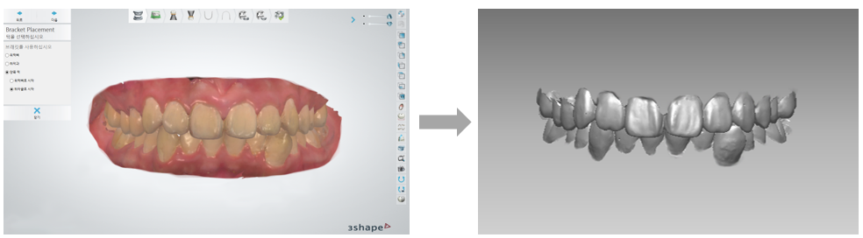
Fig 2. Intraoral scanned crown images acquired using Trios scanner and gingival areas were removed leaving the clinical crown parts.

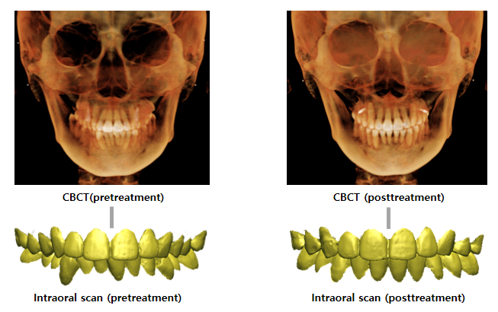
Fig 3. Crown and root images were acquired from IOS and CBCT respectively in the pretreatment and posttreatment stage.

Step II: Fabrication of pretreatment 3D tooth model
In the “MD (medical design) studio” module, the individual tooth including the root was segmented and converted into STL format. At this time, the size of the CBCT crown image should be separated as closely as possible to the size of the actual crown so that the location of root can be accurately determined. Previous studies²⁰ have shown that the roots and crowns are most similar in size when the ISO values in InVivo5 software are 600 and 900, respectively. Therefore, data for each tooth were stored separately with ISO value 600 and 900 to obtain images of the same size as the actual teeth.
To integrate intraoral scanned-crown images and CBCT root images, crown registration was performed using the ‘Register’ function in RapidformTM 2006 software. To superimpose the images, initial registration was performed by setting three corresponding points of the crown, and regional registration was performed on the based on the occlusal, buccal and lingual surfaces of the posterior teeth, and incisal, labial, and lingual surface of the anterior teeth. Then, the CBCT-scanned crown image was removed from the integrated image, and replaced with the intraoral scanned-crown image. After removing only of the crown of the CBCT image from the superimposed image, combined shell to create a 3D tooth model that combines the intraoral scanned-crown image and CBCT root image. After separating this 3D tooth model, which was produced in this way, using the function of separate cluster to shell, the indivisible 3D tooth model was fabricated by spliting the crown shells and root shells by teeth. Then, the 3D tooth model at pretreatment stage was fabricated by merging the intraoral scanned-crown images and CBCT root images before treatment (Fig 4).
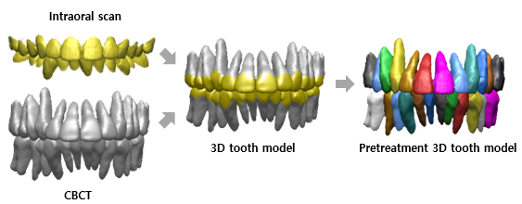
Fig 4. Fabrication of pretreatment 3D tooth model using whole dentition registration after removal of CBCT crown image, merging intraoral scanned-crown image and CBCT root image.

Step III: Fabrication of posttreatment 3D tooth model
In the same way, intraoral scanning was performed after orthodontic treatment using Trios scanner, and converted into STL format using OrthoAnalyzerTM software program. Then cut off only the clinical crown area based on the gingival line using a three-dimensional reverse engineering software to obtain the crown image of posttreatment. Posttreatment CBCT images also formed CBCT root images with ISO value 600 in the same way as pretreatment. The 3D tooth model at posttreatment stage was fabricated by same method (Fig 5).
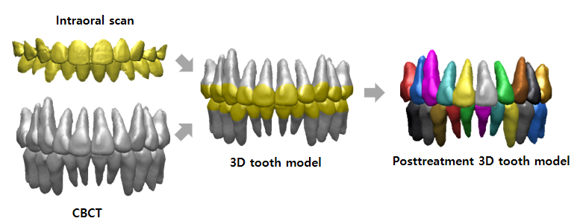
Fig 5. Fabrication of posttreatment 3D tooth model using whole dentition registration after removal of CBCT crown image, merging intraoral scanned-crown image and CBCT root image.
Step IV: Virtual setup using intraoral scanned image
The OrthoAnalyzerTM program was used for virtual setup with intraoral scanned image at the initial stage for treatment simulation, and the virtual setup model was exported to RapidformTM2006. The virtual pretreatment models had the same dental arches as the actual pretreatment models (Fig 6).
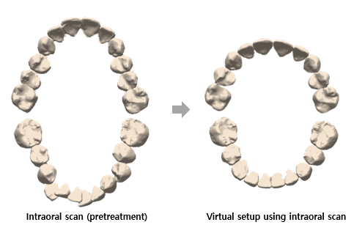
Fig 6. Virtual setup with intraoral scanned-crown image of the pretreatment stage.

Step V: Root simulation of virtual setup
To fabricate the virtual setup 3D tooth model, the virtual setup crown and segmented pretreatment 3D tooth model was integrated and crown registration was performed. Initially, the superimposition was roughly approximated using a point registration function in which more than three matching points were selected on each virtual setup crown and its respective pretreatment 3D tooth model crown. Gross errors after point registration were then corrected by the best fit registration function. The pretreatment 3D tooth model crown was then replaced with the virtual setup crown, and pretreatment 3D tooth model crown was removed from integrated image. The virtual setup 3D tooth model was fabricated by merging the virtual setup crown image and the pretreatment 3D tooth model root image (Fig 7)

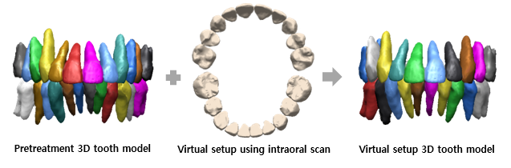
Fig 7. Fabrication of virtual setup 3D tooth model using whole dentition registration after removal of CBCT crown image, merging virtual setup crown image and pretreatment 3D tooth model root image.

Step VI: Comparison of virtual setup 3D tooth model and posttreatment 3D tooth model
To assess the virtual setup and posttreatment 3D tooth models, the inter-root distance and three-dimensional root position, and angulation were measured for each tooth, including the central incisor, lateral incisor, canine, second premolar, and first molar. To compare the teeth in virtual setup and posttreatment 3D tooth models, the surface contour of the virtual setup 3D tooth model was overlaid onto the posttreatment 3D tooth model in three-dimensional reverse engineering software.
To measure the inter-root distance, the long axis of the tooth was determined by pointing the center of the overlaid crown and each root in all three dimensions. For incisors, canines, and premolars, the point was chosen at the end of the root. For first molar, the point was chosen at the center of the root in the furcation area. Finally, using the three points, the root of the virtual setup 3D tooth model and posttreatment 3D tooth model, and center of the crown, the inter-root distance and inter-root angulation were measured for all teeth. Then, the discrepancy between the simulated and actual root position was analyzed for individually for each tooth to reduce the error caused by the morphology of the total arch (Fig 8). The investigator was trained and calibrated on how to measure the inter-root distance and angulation before collecting measurements on the 15 patients.

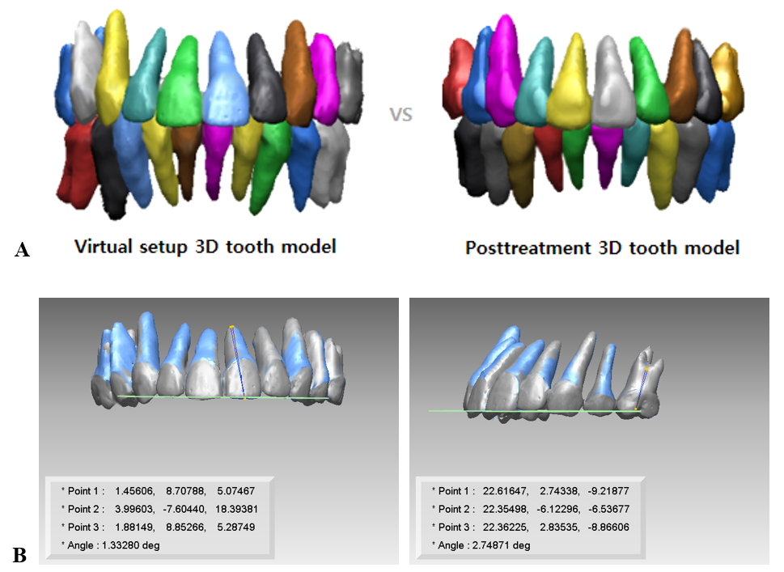
Fig 8. A, Comparison of virtual setup 3D tooth model and posttreatment 3D tooth model. B, Measurement: three-dimensional inter-root distance and inter-root angulation between the each simulated and actual 3D tooth model.

Statistical analysis
All measurements were performed by a single investigator. The paired sample t test was used to compare the tooth position in the virtual setup and posttreatment model in each tooth. A P value of <0.05 was considered statistically significant. All statistical analyses were performed using SPSS software (version 23.0; SPSS, Chicago, Ill, USA)

III. Results

A total of 300 teeth in 15 patients were evaluated by one examiner comparing the virtual setup and posttreatment 3D tooth models; central incisors, lateral incisors, canines, premolars, and 1st molars of the maxilla and mandible were compared. To assess the accuracy of the virtual setup in evaluating root position, the similarity between the virtual setup 3D tooth model and the posttreatment 3D tooth model was compared.
The means and standard deviations of the absolute value of the differences between the virtual setup 3D tooth model and the posttreatment 3D tooth model measurements are shown in Table 2 for inter-root distance and Table 3 for 3-dimensional root position. The total mean differences in all measurements were 1.84 ± 0.27 mm in maxilla and 1.79 ± 0.46 mm in mandible. Statistically significant difference of accuracy between crown and root simulation were obtained for all teeth, except maxillary lateral incisors and 1st molar.
The three-dimensional root positions in the virtual setup and posttreatment models were evaluated for each tooth. The differences are expressed by subtracting the value of the virtual setup 3D tooth model from that of the actual posttreatment 3D tooth model. A positive value on the X-axis indicates root movement in the medial direction; a positive value on the Y-axis indicates that the movement in the root direction in the maxilla and the movement in the occlusal plane direction in the mandible; and a positive value on the Z-axis indicates root movement in the forward direction. When comparing the roots of the virtual setup 3D tooth model and the posttreatment 3D tooth model, the simulated roots were located in the lateral and occlusal directions compared to the actual roots in both the maxilla and the mandible, and the Z-axis values were inconsistent. This is shown in Table 2 and 3.
Table 2. Comparison of inter-root distance between virtual setup and posttreatment in each tooth
 |  | Difference |  |  | Significance  (P value)
 |  | Mean | ± | SD | Significance  (P value)
Maxilla
Central incisor |  | 1.78 | ± | 0.61 | 0.031*
Lateral incisor |  | 2.06 | ± | 0.73 | 0.091
Canine |  | 1.84 | ± | 0.59 | 0.000‡
Second premolar |  | 2.09 | ± | 0.91 | 0.000‡
First molar |  | 1.42 | ± | 0.95 | 0.032*
Mandible
Central incisor |  | 1.74 | ± | 0.64 | 0.000‡
Lateral incisor |  | 2.16 | ± | 0.81 | 0.000‡
Canine |  | 2.07 | ± | 0.89 | 0.000‡
Second premolar |  | 1.96 | ± | 0.74 | 0.000‡
First molar |  | 1.01 | ± | 0.51 | 0.031*
Data presents the distance (mm) between simulated and actual root position at the root apex level.
SD, Standard deviation. *P < 0.05; †P < 0.01; ‡P < 0.001 by the paired t-test
 |  | Simulated |  |  |  |  |  |  |  |  | Actual |  |  |  |  |  |  |  |  |  | Difference
 |  | X |  |  | Y |  |  | Z |  |  | X |  |  |  | Y |  |  | Z |  |  | X |  |  | Y |  |  |  |  | Z
 |  | Mean | ± | SD | Mean | ± | SD | Mean | ± | SD | Mean | ± |  | SD | Mean | ± | SD | Mean | ± | SD | Mean | ± | SD | Mean | ± | SD |  | Mean |  | ± | SD
Maxilla
Central incisor |  | 4.43 | ± | 2.87 | 11.56 | ± | 4.04 | 10.66 | ± | 6.13 | 3.75 |  | ± | 2.92 | 10.75 | ± | 4.15 | 10.95 | ± | 6.19 | 0.58 | ± | 0.79* | -0.82 | ± |  | 0.91† |  | -0.42 | ± | 0.99†
Lateral incisor |  | 8.81 | ± | 3.09 | 10.50 | ± | 4.42 | 9.32 | ± | 5.73 | 8.47 |  | ± | 3.10 | 9.95 | ± | 4.51 | 9.28 | ± | 6.01 | 0.28 | ± | 1.09 | -0.55 | ± |  | 1.18† |  | -0.16 | ± | 1.39
Canine |  | 15.27 | ± | 3.91 | 14.31 | ± | 4.60 | 6.92 | ± | 4.89 | 14.85 |  | ± | 3.99 | 13.35 | ± | 4.40 | 6.77 | ± | 4.75 | 0.41 | ± | 0.88* | -0.95 | ± |  | 1.06† |  | 0.10 | ± | 0.91
Second premolar |  | 19.17 | ± | 4.56 | 11.44 | ± | 3.91 | 5.44 | ± | 3.38 | 18.49 |  | ± | 4.42 | 10.73 | ± | 4.16 | 4.67 | ± | 3.44 | 0.74 | ± | 1.27* | -0.71 | ± |  | 1.10† |  | 0.71 | ± | 0.96*
First molar |  | 21.65 | ± | 5.67 | 5.50 | ± | 3.03 | 6.23 | ± | 3.84 | 21.30 |  | ± | 5.10 | 5.19 | ± | 3.15 | 6.19 | ± | 3.93 | 0.45 | ± | 1.06 | -0.31 | ± |  | 0.98 |  | 0.21 | ± | 0.73
Mandible
Central incisor |  | 3.28 | ± | 2.38 | 22.75 | ± | 2.74 | 14.31 | ± | 4.75 | 2.98 |  | ± | 2.17 | 21.67 | ± | 2.83 | 14.75 | ± | 5.03 | 0.30 | ± | 0.72∥ | 1.08 | ± |  | 0.89∥ |  | -0.43 | ± | 0.86§
Lateral incisor |  | 7.01 | ± | 2.83 | 23.26 | ± | 3.38 | 12.65 | ± | 4.90 | 6.59 |  | ± | 3.13 | 22.19 | ± | 3.43 | 12.86 | ± | 5.17 | 0.42 | ± | 1.09∥ | 1.07 | ± |  | 0.93∥ |  | -0.21 | ± | 1.43
Canine |  | 11.81 | ± | 3.21 | 25.40 | ± | 2.63 | 8.71 | ± | 4.41 | 11.44 |  | ± | 3.47 | 24.62 | ± | 2.72 | 9.08 | ± | 4.64 | 0.37 | ± | 1.05 | 0.78 | ± |  | 1.02∥ |  | -0.38 | ± | 1.48
Second premolar |  | 16.01 | ± | 3.88 | 23.54 | ± | 3.28 | 6.88 | ± | 3.81 | 15.88 |  | ± | 3.70 | 22.23 | ± | 3.47 | 6.95 | ± | 4.04 | 0.13 | ± | 0.93 | 1.30 | ± |  | 0.77∥ |  | -0.08 | ± | 1.13
First molar |  | 20.72 | ± | 3.25 | 16.33 | ± | 4.22 | 4.01 | ± | 3.79 | 20.51 |  | ± | 3.42 | 16.02 | ± | 4.08 | 4.10 | ± | 3.87 | 0.21 | ± | 0.62 | 0.31 | ± |  | 0.70∥ |  | -0.09 | ± | 0.53
Table 3. Comparison of 3-dimensional root position between virtual setup and posttreatment in each tooth
Data presents the 3D distance (mm) between simulated and actual root position at the root apex level.
SD, Standard deviation.
X-, Y-, and Z-direction indicate mediolateral, superoinferior, and anteroposterior direction, respectively. In the maxilla, *positive value in the x-, y-, and z-direction indicates medial, apical, and anterior displacement; †negative value in the x-, y-, and z-direction indicates buccal, occlusal, and posterior displacement. In the mandible, §negative value in the x-, y-, and z-direction indicates lateral, apical, and posterior displacement;∥positive value in the x-, y-, and z-direction indicates lingual, occlusal, and anterior displacement.

Percentage differences in the values that were outside the clinically acceptable range of ±2.5° were seen in the maxillary central incisor, lateral incisor, mandibular central incisor, lateral incisor, and canine. The means and standard deviations of differences in inter-root angulation between the virtual setup 3D tooth model and the posttreatment 3D tooth model are shown in Table 4. The total mean differences in all measurements were 2.15 ± 0.89° in the maxilla and 2.23 ± 0.73° in the mandible, and these were within the ±2.5° clinically acceptable range. However, inter-root angulation differences between the virtual setup and posttreatment models were statistically significant in the maxillary canine (P<0.05) and mandibular canine (P<0.01).

Table 4. Difference of inter-root angulation between virtual setup and posttreatment in each tooth
 |  | Simulated |  |  |  | Actual |  |  |  | Difference |  |  | Significance  (P value)
 |  | Mean | ± | SD |  | Mean | ± | SD |  | Mean | ± | SD | Significance  (P value)
Maxilla
Central incisor |  | 85.40 | ± | 18.11 |  | 85.88 | ± | 25.38 |  | 3.21 | ± | 2.21 | 0.514
Lateral incisor |  | 82.83 | ± | 32.17 |  | 83.35 | ± | 26.19 |  | 2.99 | ± | 2.56 | 0.468
Canine |  | 74.43 | ± | 21.04 |  | 75.27 | ± | 18.87 |  | 1.78 | ± | 1.50 | 0.046*
Second premolar |  | 82.63 | ± | 19.77 |  | 82.14 | ± | 19.22 |  | 1.25 | ± | 1.09 | 0.107
First molar |  | 82.76 | ± | 24.03 |  | 82.63 | ± | 20.42 |  | 1.51 | ± | 1.19 | 0.717
Mandible
Central incisor |  | 84.73 | ± | 35.67 |  | 86.23 | ± | 10.10 |  | 2.83 | ± | 3.19 | 0.051
Lateral incisor |  | 85.83 | ± | 13.17 |  | 86.54 | ± | 05.29 |  | 2.55 | ± | 2.13 | 0.243
Canine |  | 75.74 | ± | 31.74 |  | 77.83 | ± | 30.95 |  | 2.88 | ± | 2.42 | 0.001†
Second premolar |  | 81.36 | ± | 23.43 |  | 81.05 | ± | 18.14 |  | 1.40 | ± | 1.28 | 0.371
First molar |  | 79.33 | ± | 23.14 |  | 79.50 | ± | 22.29 |  | 1.49 | ± | 0.89 | 0.601
Data presents in degree (°) between simulated and actual root axis at extraction site.
SD, Standard deviation. *P < 0.05; † P < 0.01; ‡P < 0.001 by the paired t-test.

IV. Discussion

The position and parallelism of the root and the occlusion of the crown are important factors in orthodontic treatment. Proper bracket positioning according to Andrew’s six keys is necessary in this regard. Currently, the root position is primarily evaluated according to the panorama taken at the first visit.⁸⁻¹⁰ The American Board of Orthodontics recommends evaluation of root angulation using panoramic radiographs; however, these often contain distortions, resulting in an inaccurate portrayal of root angulations.²¹ Although the introduction of CBCT has been helpful in orthodontics by enabling three-dimensional positioning of the roots, many studies emphasize the ALARA (As Low As Reasonably Achievable) principle, arguing that the root position should not be replaced by CBCT if it is sufficiently understood by the study model or panorama alone.²² Thus, several studies have focused on methods for identifying the three dimensional root position while reducing radiation exposure.^{11,12,23-31} In particular, the development of laser scanners has led to studies that merge the laser-scanned crown of cast model with the root from CBCT images to determine the three-dimensional position of the root.^{14,32-35} This procedure has also been found to be clinically useful in terms of accuracy.^{15,16} Furthermore, recent studies have been also focused on creating individual composite tooth models by combining intraoral scanned-crown data and CBCT root data.^{17,18,36-40}
Currently, bracket positioning is accomplished using intraoral scanned data; it depends solely on the crown position as intraoral scanned-images do not contain information about the root. Moreover, the intraoral scanned data may be disturbed in patients with gingival swelling or heavy salivation, which can complicate digital bracketing based on accurate information of the root position. Therefore, the objective of this study was to determine whether the virtual setup could be used for direct bracket positioning without root information at pretreatment stage.
Pretreatment and posttreatment 3D tooth model were created using intraoral scanned images and CBCT images acquired during each stage. Using the OrthoAnalyzerTM program, a virtual setup was prepared with intraoral scanned images taken at the initial stage for treatment simulation. The virtual setup crown images were exported to STL files using a three-dimensional reverse engineering software, and the pre-made pretreatment 3D tooth model root was combined to predict the location of the root. To reduce errors caused by eyesight fatigue while developing the 3D tooth model, the operator made only one 3D tooth model per week.
The accuracy of the simulated virtual setup root position was evaluated using the CBCT images taken after orthodontic treatment, the gold standard, and the difference between the simulated and actual posttreatment root positions was measured by comparing the virtual setup 3D tooth model with the posttreatment 3D tooth model. The predicted root position was evaluated as the difference in the three dimensional position and the root axis angle. The average difference between the three dimensional root positions was 1.84 ± 0.27 mm in the maxilla and 1.79 ± 0.46 mm in the mandible, and the average difference between the three dimensional root axis angles was 2.15 ± 0.89° on average in the maxilla and 2.23 ± 0.73° in the mandible
Measurements of inter-root distance and angulation in each tooth were used to compare the virtual setup 3D tooth model and posttreatment 3D tooth model. If the methods reported in this study to measure inter-root distance and angulation for both the virtual setup and the actual models are consistent and precise, then the differences will be accurately reflected between these two sets of measurements.
Root positions in the virtual setup and posttreatment 3D tooth models showed a difference of more than 1 mm in all teeth, and statistically significant differences were observed in all teeth, except the maxillary lateral incisor. The values of the maxillary and mandibular incisors tended to be slightly greater than those of the other teeth. In particular, the difference in the anterior teeth was thought to be due to prominent root resorption in the incisors after orthodontic treatment, especially compared to the pretreatment stage. In addition, there are many other factors that can cause differences in root size and shape such as noise, voxel size, contrast variance, and segmentation accuracy. A potential solution for this would be to use a low-dose spiral CT rather than CBCT as it has been shown to generate high-quality images for orthodontic diagnosis without a significant increase of radiation for patients.⁴¹
Inter-root angulation measurements in the virtual setup and posttreatment 3D tooth models showed a difference of more than 1 degree in all teeth. In particular, there was a difference of more than 2 degrees in the maxillary and mandibular anterior teeth, and significant differences were observed in the maxillary and mandibular canine. This is because it was difficult to distinguish the root axis in these case. As measuring the root axis involves comparing the angular difference by marking the crown and the root apex, it was difficult to accurately measure the root axis in such cases. It is also apparent that positioning the bracket using solely the crown image does not accurately reflect the root location if the incisal edge of the anterior tooth does not have an ideal shape of crown due to attrition or abnormal form.
In this study, there was a significant difference between each measurement when a virtual setup was prepared without any information about the crown and posttreatment. This indicates that a virtual setup using crown images alone does not reflect 100% of the actual root position, and digital bracketing setup using intraoral scanned image that do not consider the root position also has practical limitations. Moreover, there are still technical limitations. There is no program that combines CBCT root images and intraoral scanner crown images, and the process of making 3D tooth models is time consuming. However, these shortcomings can be sufficiently overcome by future technological advances. Based on this, there is a need to develop a new virtual setup program that can simulate root position while integration crown information.

V. Conclusion

The present virtual setup protocol using intraoral scans showed clinically acceptable accuracy for root position simulation. The study demonstrated that compared to the posttreatment 3D tooth model, the virtual setup tooth model did not fully consider the root positioning in bracket positioning. Thus, for accurate and precise treatment simulation, a virtual setup using both crown and root data should be implemented in clinical practice.

References
- Andrews LF. The six keys to normal occlusion. Am J Orthod 1972;62:296-309.

- Balut N, Klapper L, Sandrik J, Bowman D. Variations in bracket placement in the preadjusted orthodontic appliance. Am J Orthod Dentofac Orthop 1992;102:62-7.

- Miethke RR. Third order tooth movements with straight wire appliances. Influence of vestibular tooth crown morphology in the vertical plane. J Orofac Orthop 1997;58:186-97.

- Miethke RR, Melsen B. Effect of variation in tooth morphology and bracket position on first and third order correction with preadjusted appliances. Am J Orthod Dentofac Orthop 1999;116:329-5

- Germane N, Bentley BE, Isaacson RJ. Three biologic variables modifying faciolingual tooth angulation by straight-wire appliances. Am J Orthod Dentofac Orthop 1989;96:312–9.

- Carlsson R, Rönnerman A. Crown-root angles of upper central incisors. Am J Orthod 1973;64:147-54.

- Bryant RM, Sadowsky PL, Hazelrig JB. Variability in three morphologic features of the permanent maxillary central incisor. Am J Orthod 1984;86:25-32.
- Mckee IW, Glover KE, Williamson PC, Lam EW, Heo G, Major PW. The effect of vertical and horizontal head positioning in panoramic radiography on mesiodistal tooth angulations. Angle Orthod 2001;71:442-51.
- Garcia-Figueroa MA, Raboud DW, Lam EW, Heo G, Major PW. Effect of buccolingual root angulation on the mesiodistal angulation shown on panoramic radiographs. Am J Orthod Dentofacial Orthop 2008;134:93-9.

- Owens AM, Johal A. Near-end of treatment panoramic radiograph in the assessment of mesiodistal root angulation. Angle Orthod 2008;78:475-81.

- Hubert G. Computerized dentistry: Benefits and challenges. CJRDP 2009;2:3-4.

- Swennen GR, Mollemans W, Schutyser F. Three-Dimensional Treatment planning of orthognathic surgery in the era of virtual imaging. J Oral Maxillofac Surg 2009;67:2080-92.

- Guo H, Zhou J, Bai Y, Li S. A Three-demensional setup model with dental roots. J Clin Orthod 2011;45:209-16.

- Macchi A, Carrafiello G, Cacciafesta V, Norcini A. Three-dimensional digital modeling and setup. Am J Orthod Dentofacial Orthop 2006;129:605-10.

- Kihara T, Tanimoto K, Michida M, Yoshimi Y, Nagasaki T, Murayama T, et al. Construction of orthodontic setup models on a computer. Am J Orthod Dentofacial Orthop 2012;141:806-13.
- Lightheart KG, English JD, Kau CH, Akyalcin S, Bussa HI Jr, McGrory KR, et al. Surface analysis of study models generated from orthoCAD and cone-beam computed tomography imaging. Am J Orthod Dentofacial Orthop 2012;141:686-93.

- Lee RJ, Weissheimer A, Pham J, Go L, de Menezes LM, Redmond WR, et al. Three-dimensional monitoring of root movement during orthodontic treatment. Am J Orthod Dentofacial Orthop 2015;147:132-42.

- Lee RJ, Pham J, Choy M, Weissheimer A, Dougherty HL, Sameshima GT, et al. Monitoring of typodont root movement via crown superimposition of single cone-beam computed tomography and consecutive intraoral scans. Am J Orthod Dentofacial Orthop 2014;145:399-409.

- Grünheid T, McCarthy SD, Larson BE. Clinical use of a direct chairside oral scanner: an assessment of accuracy time and patient acceptance. Am J Orthod Dentofacial Orthop 2014;146:673-82.

- Choo HH, Composite Tooth Model constructed by merging intraoral-scanned crown and cone-beam computed tomography root, Unpublished doctoral dissertation, Chonnam National University, 2018

- Casko JS, Vaden JL, Kokich VG, Damone J, James RD, Cangialosi TJ, et al. American Board of Orthodontics: Objective grading system for dental casts and panoramic radiographs. Am J Orthod Dentofacial Orthop 1998;114:589-99.
- Mah JK, Huang JC, Choo H. Practical applications of cone-beam computed tomography in orthodontics. J Am Dent Assoc 2010;141:7S-13S.

- Sherrard JF, Rossouw PE, Benson BW, Carrillo R, Buschang PH. Accuracy and reliability of tooth and root lengths measured of cone-beam computed tomographs. Am J Orthod Dentofacial Orthop 2010;137:S100-8.

- Moshiri M, Scarfe WC, Hilgers ML, Scheetz JP, Silveira AM, Farman AG. Accuracy of linear measurements from imaging plate and lateral cephalometric images derived from cone-beam computed tomography. Am J Orthod Dentofacial Orthop 2007;132:550-60.

- Cattaneo PM, Bloch CB, Calmar D, Hjortshøj M, Melsen B. Comparison between conventional and cone-beam computed tomography-generated cephalograms. Am J Orthod Dentofacial Orthop 2008;134:798-802.

- Grauer D, Cevidanes LS, Proffit WR. Working with DICOM craniofacial images. Am J Orthod Dentofacial Orthop 2009;136:460-70.

- Su TS, Sun J. Comparison of repeatability between intraoral digital scanner and extraoral digital scanner: an in-vitro study. J Prosthodont Res 2015;59:236-42.

- Akyalcin S, Cozad BE, English JD, Colville CD, Laman S. Diagnostic accuracy of impression-free digital models. Am J Orthod Dentofacial Orthop 2013;144:916-22.

- Cuperus AM, Harms MC, Rangel FA, Bronkhorst EM, Schols JG, Breuning KH. Dental models made with an intraoral scanners: A validation study. Am J Orthod Dentofacial Orthop 2012;142:308-13.

- Ender A, Mehl A. Accuracy of complete-arch dental impressions: a new method of measuring trueness and precision. J Prosthet Dent 2013;109:121-8.

- Hurt AJ. Digital technology in the orthodontic laboratory. Am J Orthod Dentofacial Orthop 2012;141:245-7.

- Nayar S, Mahadevan R. A paradigm shift in the concept for making dental impressions. J Pharm Bioallied Sci 2015;7:S213-5.

- Rheude B, Sadowsky PL, Ferriera A, Jacobson A. An evaluation of the use of digital study models in orthodontic diagnosis and treatment planning. Angle Orthod 2005;75:300-4.

- Chandran DT1, Jagger DC, Jagger RG, Barbour ME. Two-and three-dimensional accuracy of dental impression materials: Effects of storage time and moisture contamination. BioMed Mater Eng 2010;20:243-9.
- Sousa MV, Vasconcelos EC, Janson G, Garib D, Pinzan A. Accuracy and reproducibility of 3-dimensional digital model measurements. Am J Orthod Dentofacial Orthop 2012;142:269-73.

- Hayashi K, Sachdeva AU, Saitoh S, Lee SP, Kubota T, Mizoguchi I. Assessment of the accuracy and reliability of new 3-dimensional scanning devices. Am J Orthod Dentofacial Orthop 2013;144:619-25.

- Naidu D, Freer TJ. Validity, reliability, and reproducibility of the iOC intraoral scanner: a comparison of tooth widths and Bolton ratios. Am J Orthod Dentofacial Orthop 2013;144:304-10.

- Wiranto MG, Engelbrecht WP, Tutein Nolthenius HE, van der Meer WJ, Ren Y. Validity, reliability, and reproducibility of linear measurements on digital models obtained from intraoral and cone-beam computed tomography scans of alginate impressions. Am J Orthod Dentofacial Orthop 2013;143:140-7.

- Brawek PK, Wolfart S, Endres L, Kirsten A, Reich S. The clinical accuracy of single crowns exclusively fabricated by digital workflow-the comparison of two systems. Clin Oral Investig 2013;17:2119-25.

- Logozzo S, Zanetti EM, Franceschini G, Kilpelä A, Mäkynen A. Recent advances in dental optics-part I: 3D intraoral scanners for restorative dentistry. Opt Lasers Eng 2014;54:203-21.

- Cordasco G, Portelli M, Militi A, Nucera R, Lo Giudice A, Gatto E, Lucchese A. Low-dose protocol. Prog Orthod 2013;14:24.
콘빔 CT 영상과 구강 스캔 영상을 활용한
치근 위치 시뮬레이션을 위한 3차원 virtual setup의 정확도에 관한 연구

박미리내

전남대학교 대학원 치의학과
(지도교수: 이경민)

(국문초록)
연구목적: 교정치료의 결과를 예측하기 위해 시행되고 있는 가상 치아이동은 현재 치관 영상만을 이용하여 이루어지고 있으며, 치근 정보 없이 치관 정보만을 이용한 가상 치아이동이 실제 치근의 이동을 얼마나 반영하고 있는지에 대한 평가가 필요하다. 따라서, 소구치 발치를 동반한 교정치료를 받은 환자를 대상으로 이들의 콘빔 CT영상과 구강 스캔 영상을 이용하여 가상 치아이동 시의 치근 위치와 실제 치료 후의 치근 위치를 비교 분석했다.

연구방법: 교정 치료 전, 후에 해당하는 콘빔 CT영상 및 구강 스캔 영상이 확보된 환자 중, 소구치 발치를 동반한 교정치료를 완료한 15명의 환자를 대상으로 연구를 시행하였다. 구강 스캔 영상과 콘빔 CT영상을 병합하여 치료 전, 후의 3차원 치아 모델을 제작하였다. 동일한 방법으로 치료 전 구강 스캔 치관영상을 이용하여 가상 치아이동 후 치료 전 콘빔 CT치근영상과 병합하여 3차원 가상 치아 모델을 제작하였다. 치료 후 3차원 치아 모델의 치근과 가상 치아 모델을 비교하였으며, 각 모델의 치근 사이 직선 거리와 각도를 측정하고, paired t-test를 이용하여 이를 통계적으로 비교 분석하였다.

연구결과: 치료 후 3차원 치아 모델과 가상 치아 모델 치근의 평균 불일치는 상악에서 1.84 ± 0.27 mm 및 2.15 ± 0.89°, 하악에서 1.79 ± 0.46 mm 및 2.23 ± 0.73°였다. 실제 치료 후 치근 위치와 가상 치아 모델의 치근 위치는 통계적으로 유의한 차이를 보였다.

결론: 따라서 본 연구를 통해 치관 정보만을 이용한 가상 치아 이동시 치근의 위치는 실제 치근의 위치와 차이가 존재하며, 이를 보완하기 위해 기존의 치관 정보와 함께 치근 정보를 모두 사용하는 새로운 가상 치아 이동 방법이 필요하다.

